ZIMS Final DocumeNt
Prepared By

  - Group 06

Hans Lowa, Tinashe Maphosa, Abe Kumari, Sive Gwaza, Thandile Jama, Katlego Mamabolo
Contents
Project Scope 2
Physical Data Model 3
Physical Process Model 4
Database Schema (SQL) 5
All Sql Used For: 6
Maintaining Booking Table (Abe Kumari – Code Screenshots) 6
Maintaining Event (Sive Gwaza – Code Screenshots) 7
Maintaining Tourists (Hans Lowa - Code Screenshots): 8
Query Database – Reports (Tinashe Maphosa – Code Screenshots) 9
Maintaining a child entity (Code) 10
Reports Generated 13
User Manual 14
DETAIL DAIRY (Time Spent by each individual coding) 17
Abe Kumari 17
Katlego Mamabolo 18
Tinashe Maphosa 20
Sive Gwaza 21
Thandile Jama 23

Project Scope

- Maintain Event types
- Maintain Tourists
- Maintain Booking Events
- Receive Payments
- Arrive for Events
- Exit the Zoo
- Request Reports
  - Number of bookings per week per time periods
  - Top 5 events per time period

Physical Data Model

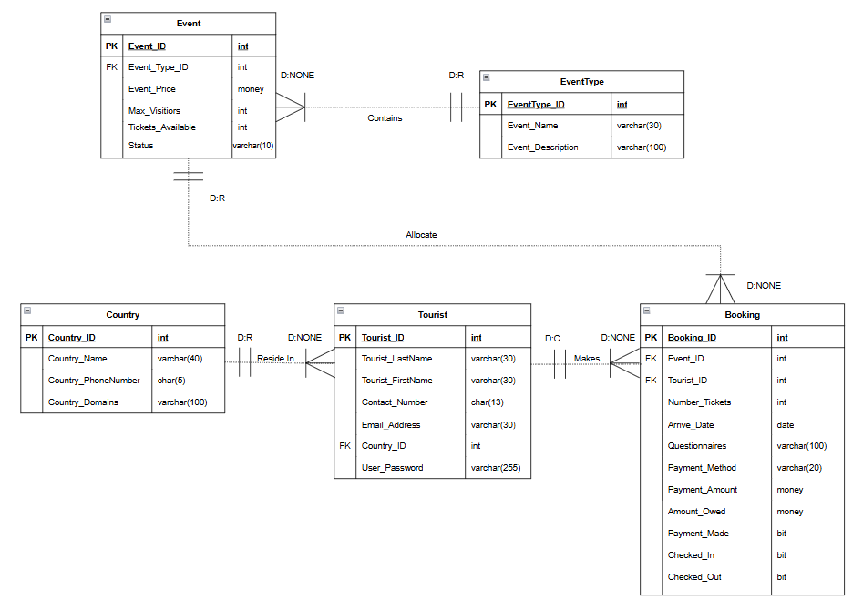

Physical Process Model

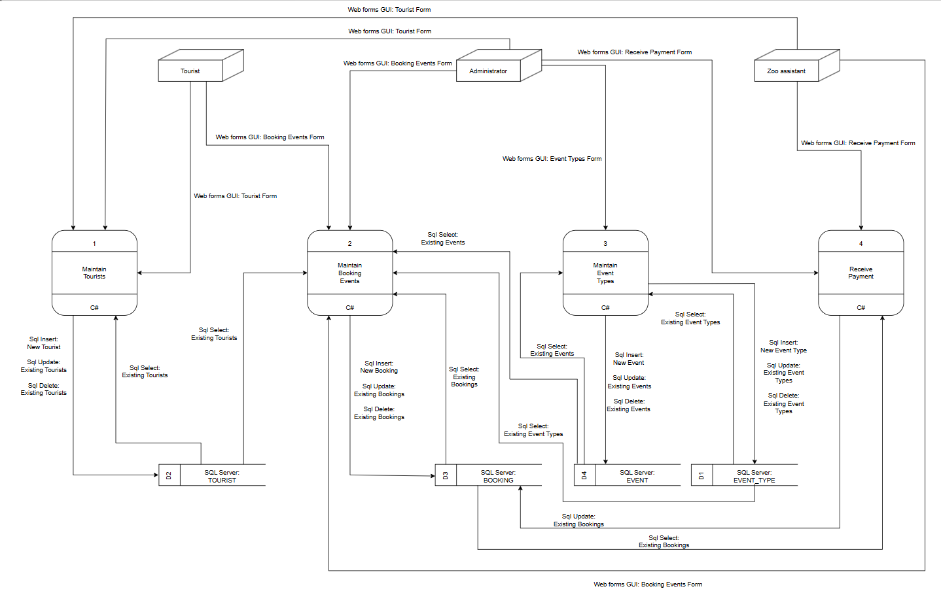

Database Schema (SQL)
- Creating the database tables with constraints (SM

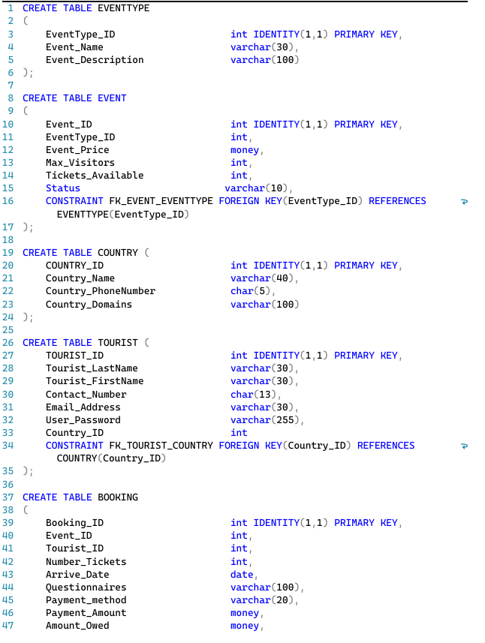
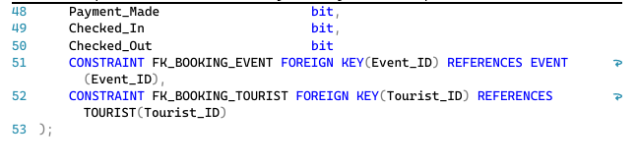

All Sql Used:

Maintaining Booking Table (Abe Kumari – Code Screenshots)
Insert:
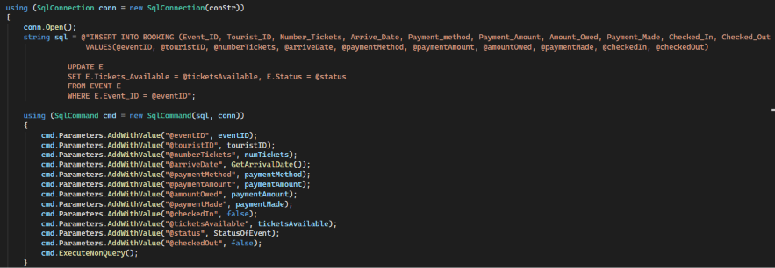
Update:
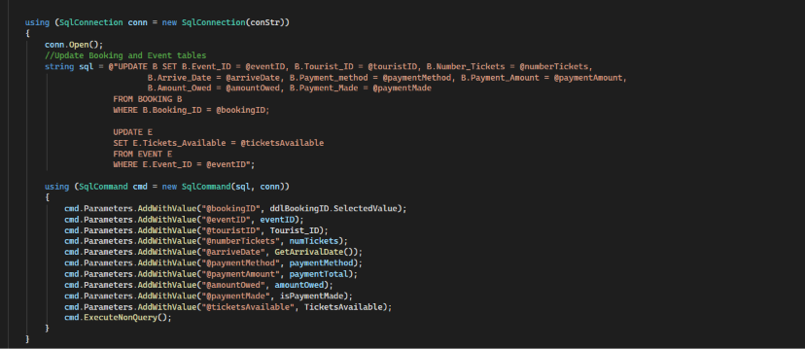
Delete:
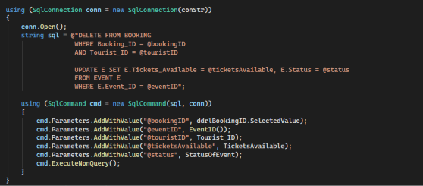

Maintaining Event (Sive Gwaza – Code Screenshots)
Insert Event
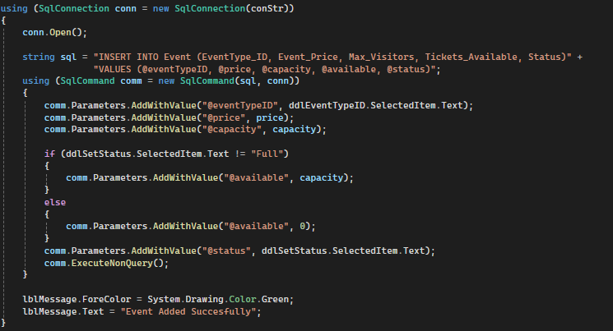
Update Event
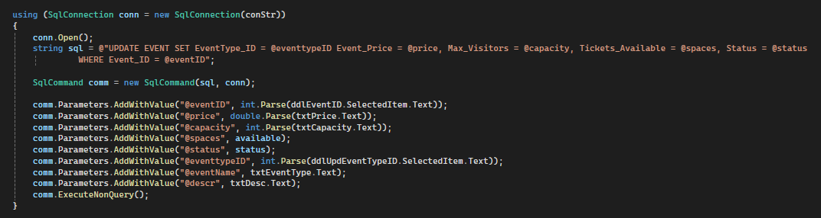

Delete event
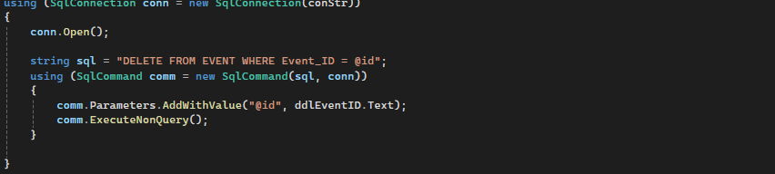

Maintaining Tourists (Hans Lowa - Code Screenshots):
Insert Tourists:
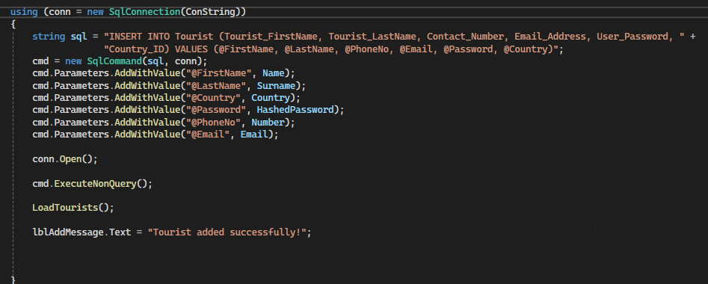
Update Tourist:
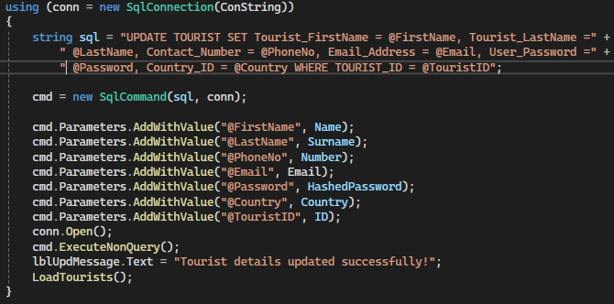
Delete Tourist:
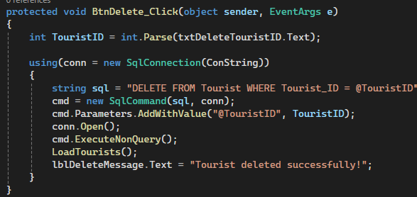

Query Database – Reports (Tinashe Maphosa – Code Screenshots)
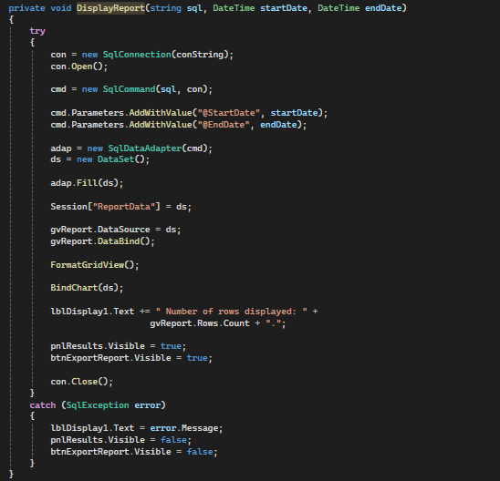
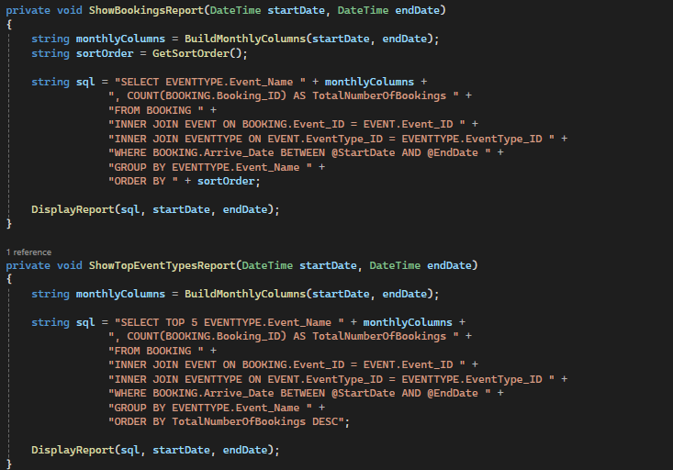

Maintaining a child entity (Code)
- Provide screen shots for the programming code maintaining a child entity
- Made use of methods (to efficiency of code)

Maintaining Booking Table
Insert booking
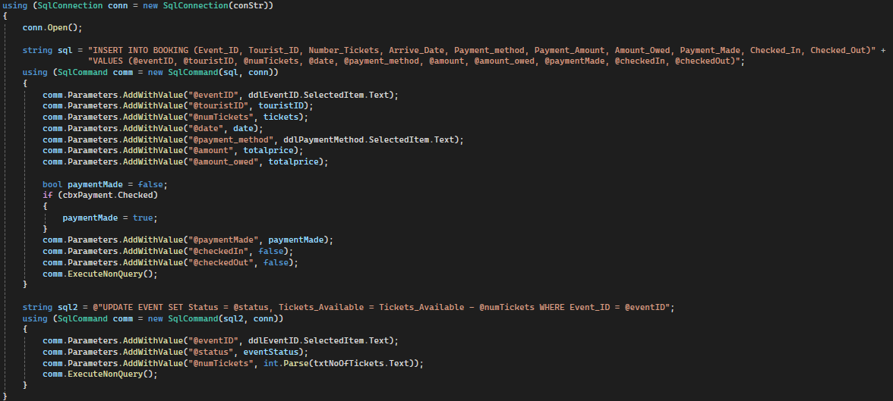
Update booking
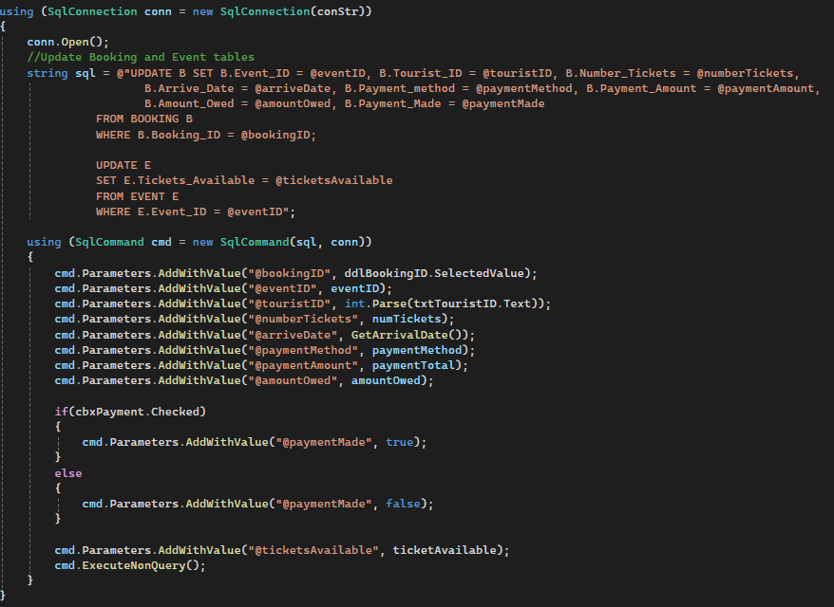

Delete Booking
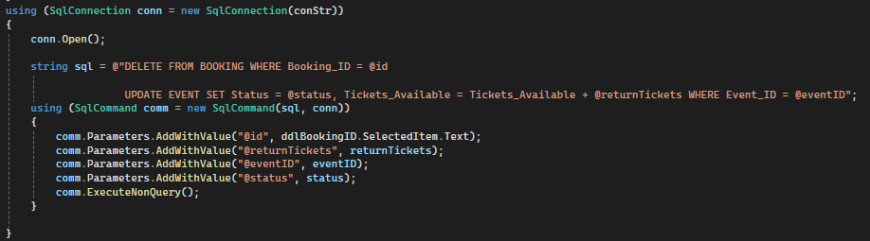
Methods used
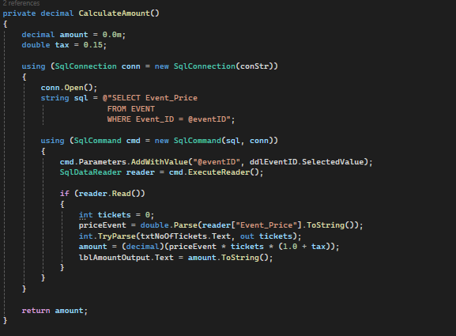
The methods were used to reload the grid views at page load and after the user has completed added a booking.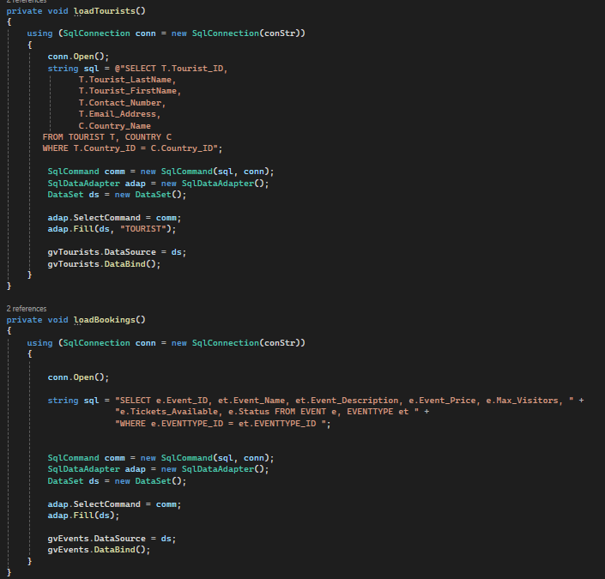
Used to confirm that id exists in table
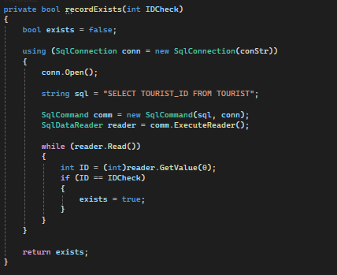
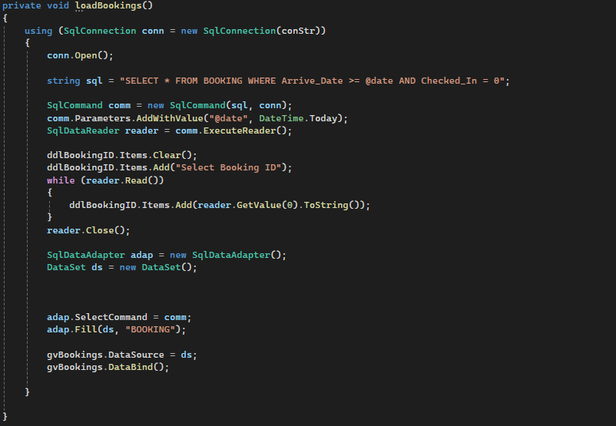
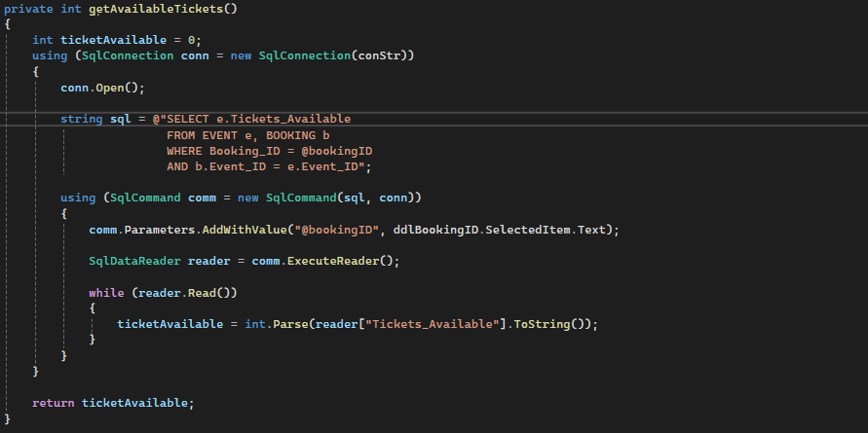
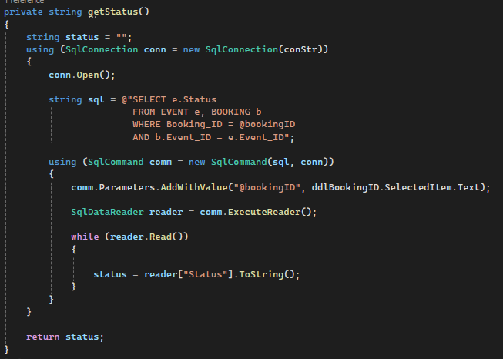

Reports Generated
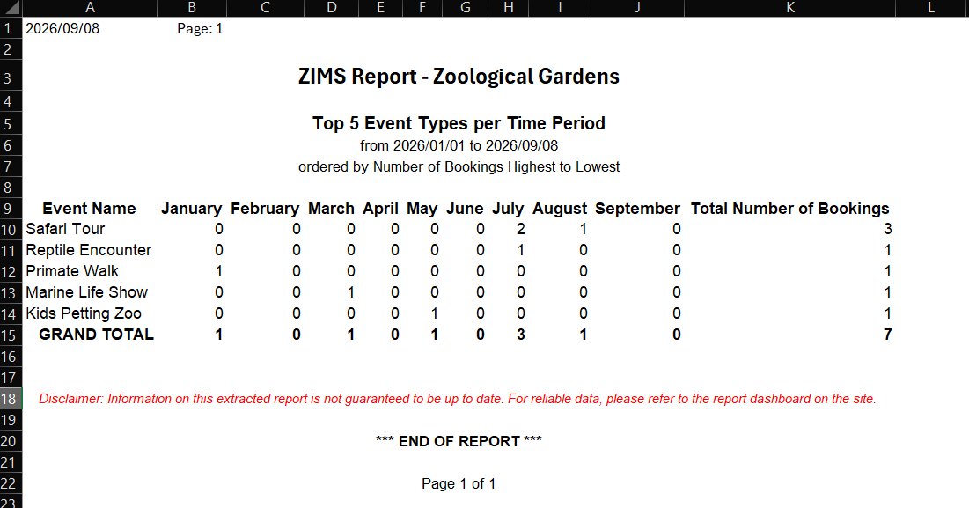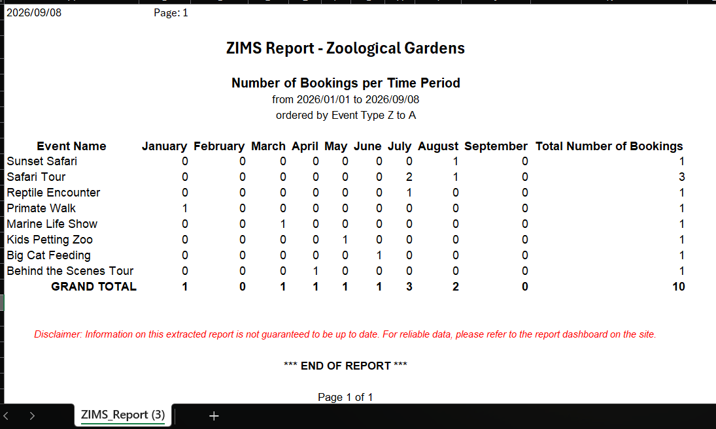

User Manual
Zoo Information Management System (ZIMS)
User Guideline
1. System Requirements
Before using the system, ensure that the computer has the following:
- Operating System: Windows 10 or later
- RAM: Minimum 8 GB (Recommended 16 GB)
- Storage: At least 10 GB of available space (SSD recommended)
- Processor: Intel Core i5 / AMD Ryzen 5 or better
- Internet/Wi-Fi: Required for downloading and installing the necessary software and packages
- Visual Studio Community: Installed
- SQL Server: Installed
- SQL Server Management Studio (SSMS): Installed

2. Database Setup
The system uses Microsoft SQL Server for its database.
Step 1: Open SQL Server Management Studio
Open SQL Server Management Studio (SSMS) and connect to your SQL Server instance.
Step 2: Create the Database
Create a new database called:
zims.db
Alternatively, the SQL scripts can be executed while connected to the default Master database if the script creates the database.
Step 3: Create the Tables
Open the provided:
zims.sql
Execute the script in SSMS. This will create the required tables and relationships for the system.

Step 4: Insert Initial Data
Open the provided:
zims.data.setup.sql
Execute the script after running zims.sql. This will insert the initial data required by the system.
Important: Run zims.sql first and zims.data.setup.sql second.

3. Running the System
- Open Visual Studio Community.
- Open the ZIMS project/solution (Project.sln).
- Connect Visual Studio to SSMS (1.Server Explorer, 2. Data Connections (right-click to add database), 3. Connect to database created on SSMS)
- Ensure that the database connection string is correctly configured.
- Make sure SQL Server is running.
- Press Start ▶ or F5 to run the system.
- The system will open in the web browser.

4. Tourist Login
First-time Tourist
If you are using the system for the first time as a tourist:
- Select Register/Create Account.
- Enter your required details.
- Create your password.
- Submit the registration.
- Use your newly created account to log in.
Existing Tourist
If you already have an account:
- Enter your registered email address.
- Enter your password.
- Select Login.

5. Staff and Admin Login
Initial Staff/Admin Login
The initial login credentials are:
- Email: Any email ending with @zims.com (e.g. Admin@zims.com)
- Password: admin123
Staff and Admin initially use these credentials to access the system.
Admin Access
Once inside the system, Admin access uses:
- Required on Maintain EventTypes Form
- Email: admin@zims.com
- Password: ZimsAdmin
Note: Use the credentials provided by the system administrator if they have been changed from the default credentials.

DETAIL DAIRY (Time Spent by each individual coding)

Abe Kumari
Dates (from 29/08/2026 till 08/09/2026)
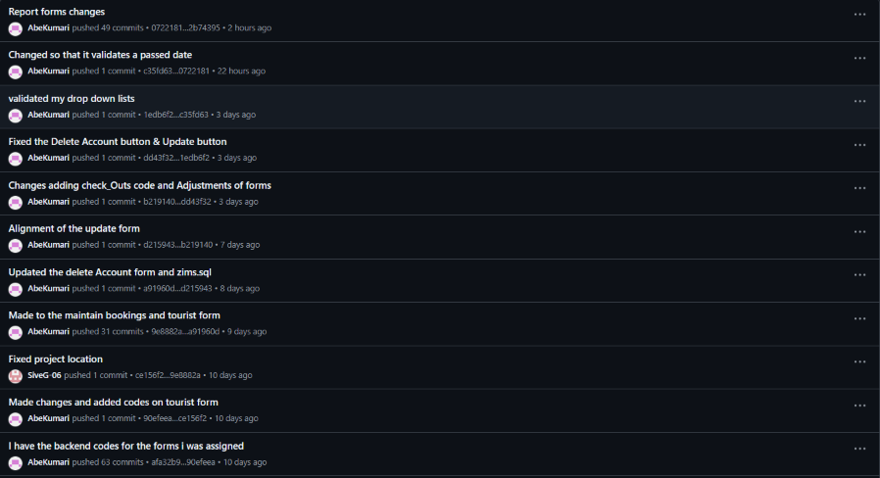
Dates (from 11/08/2026 till 23/08/2026)
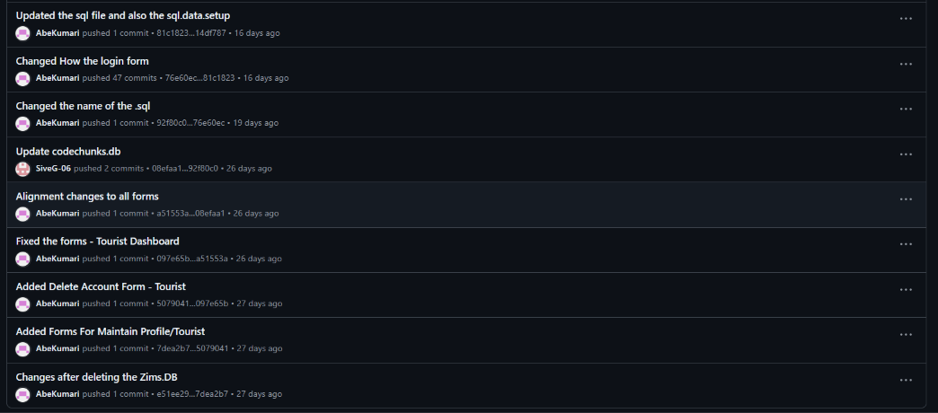
Dates (from 10/08/2026 till 11/08/2026)
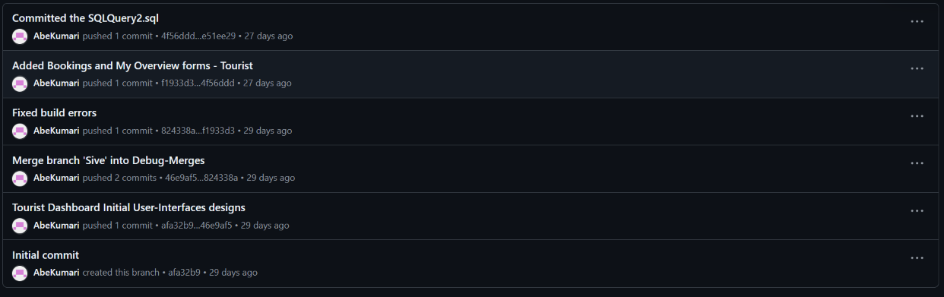

Katlego Mamabolo
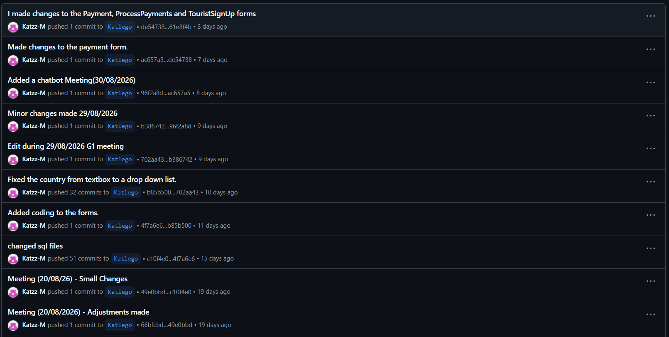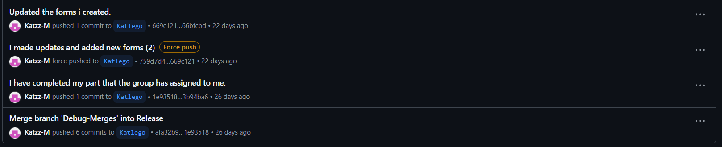

Hans Lowa
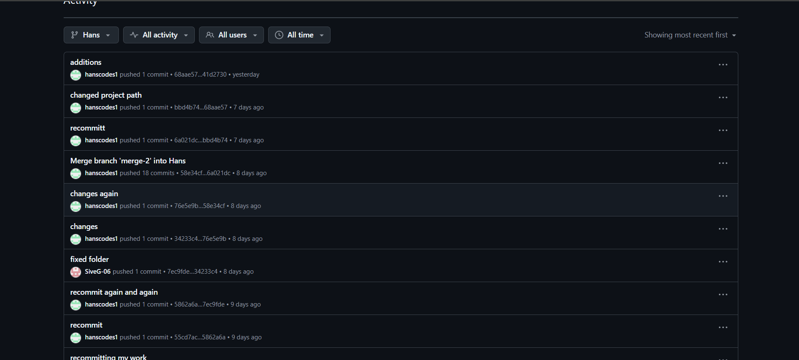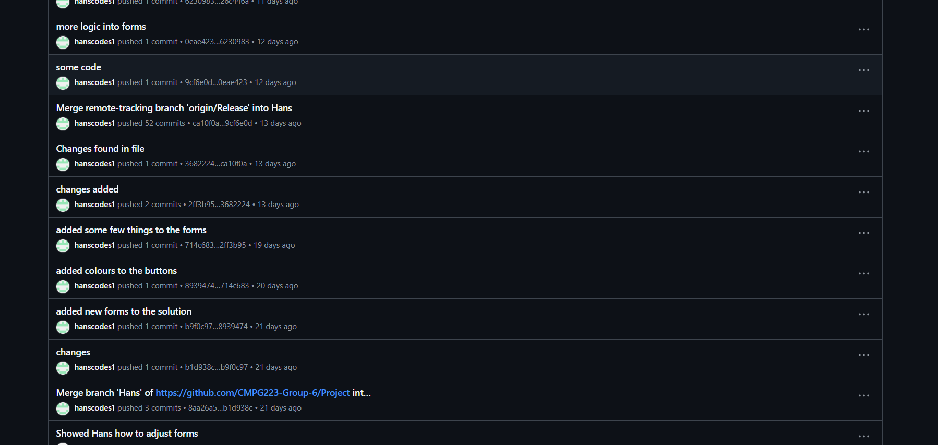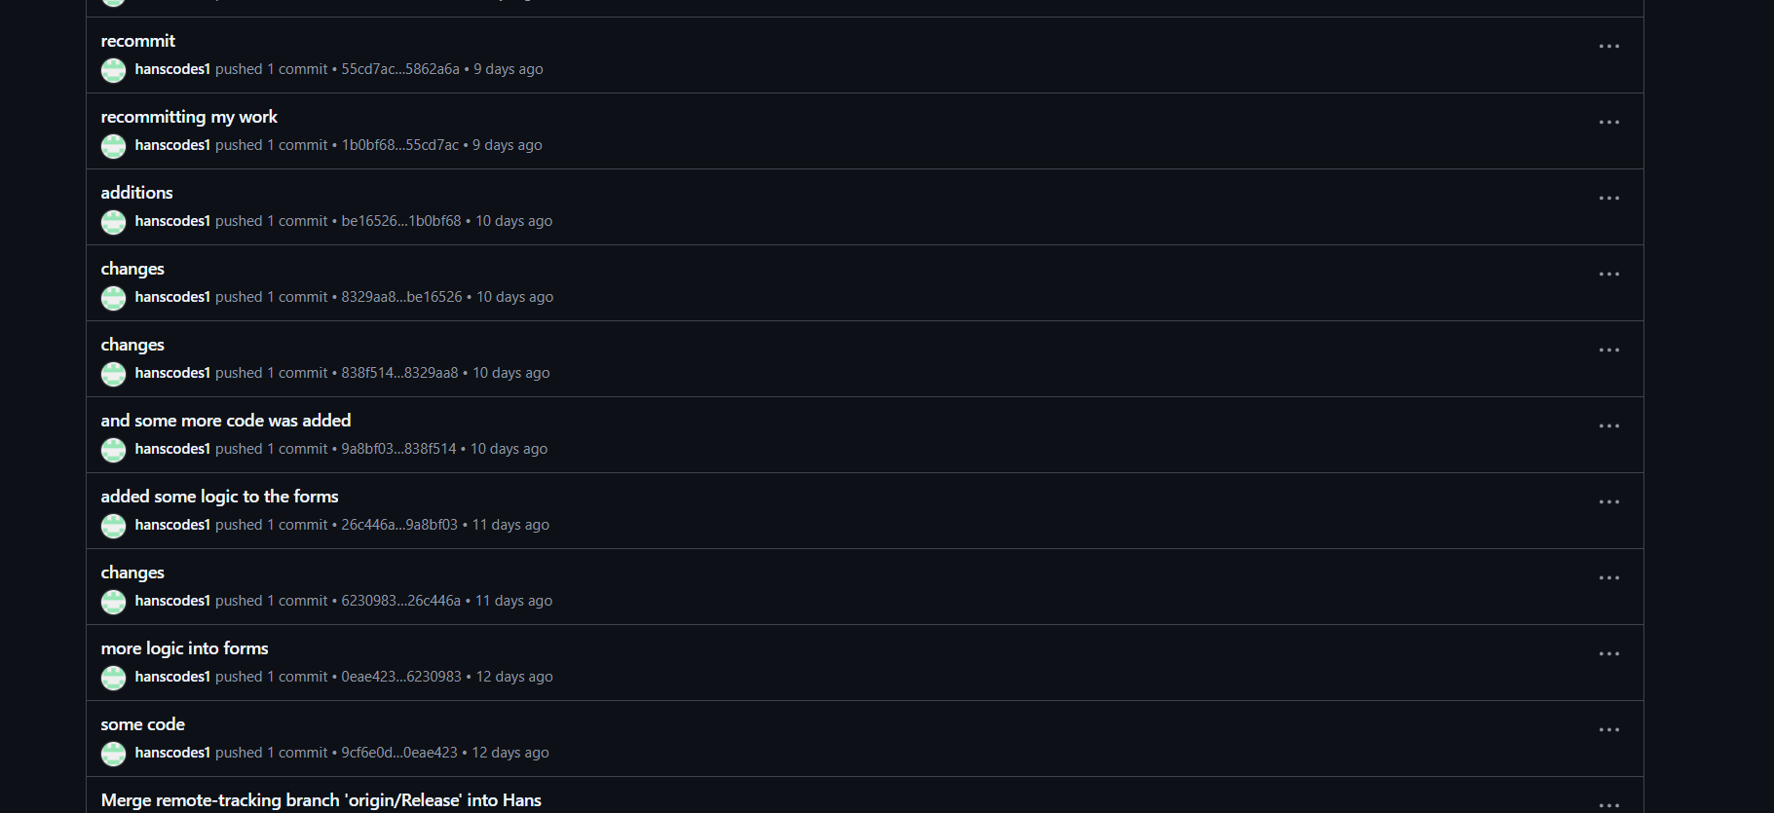

Tinashe Maphosa
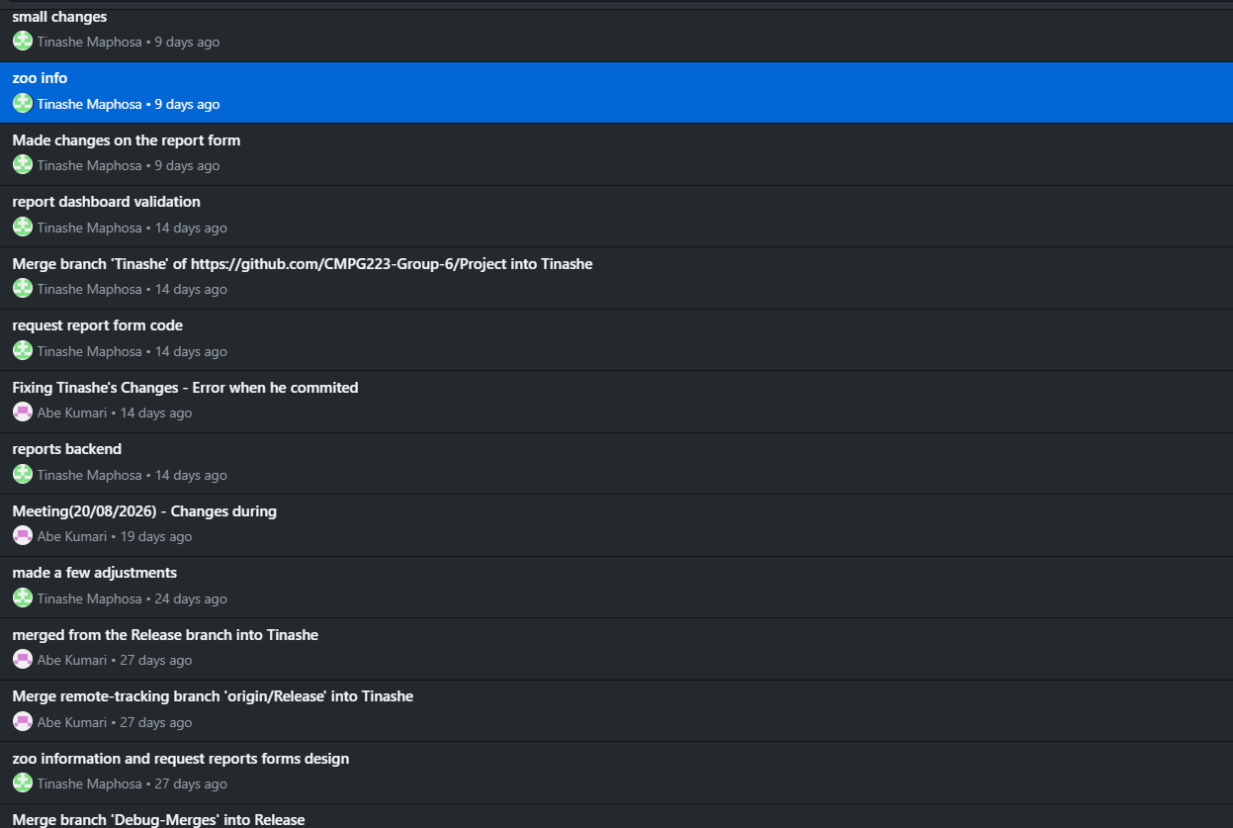

Sive Gwaza
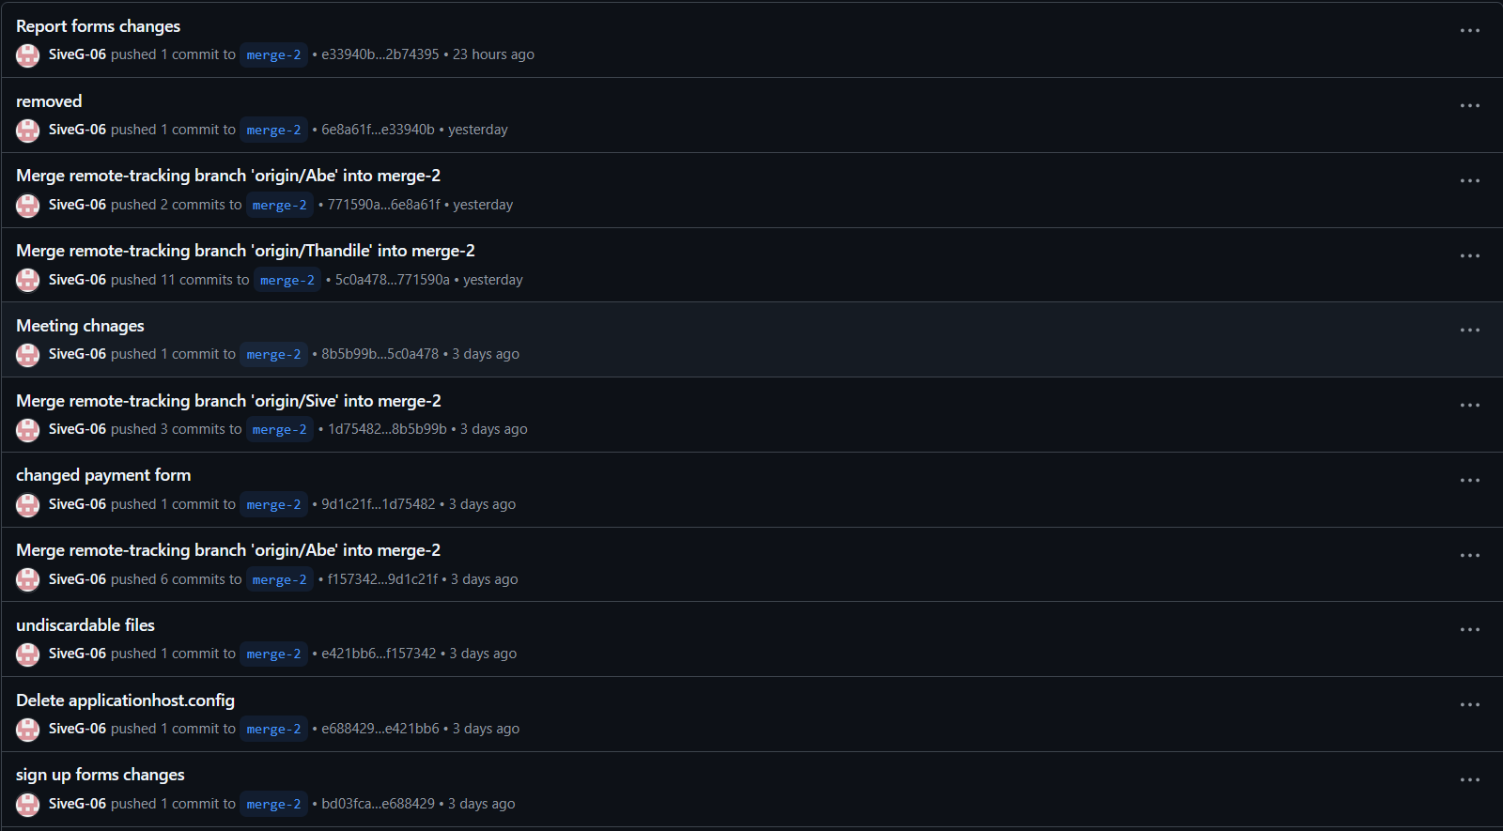
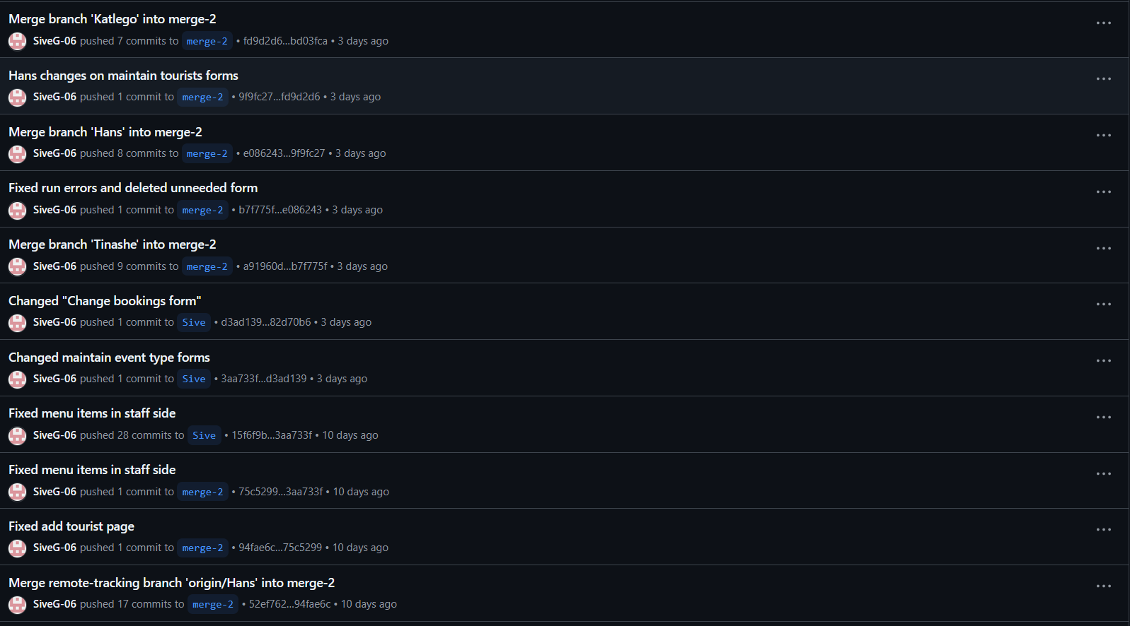
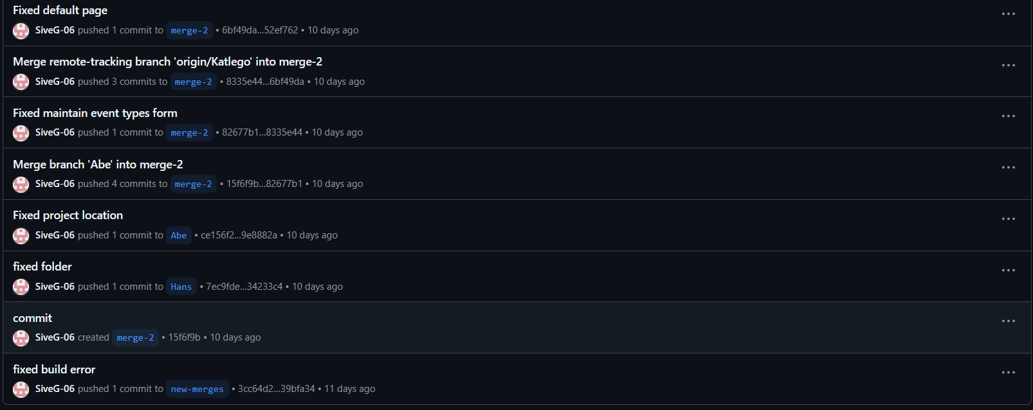
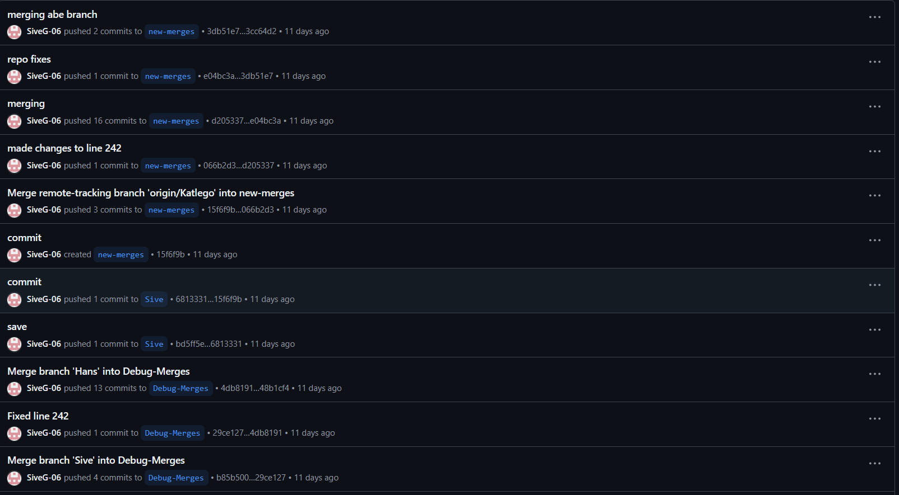
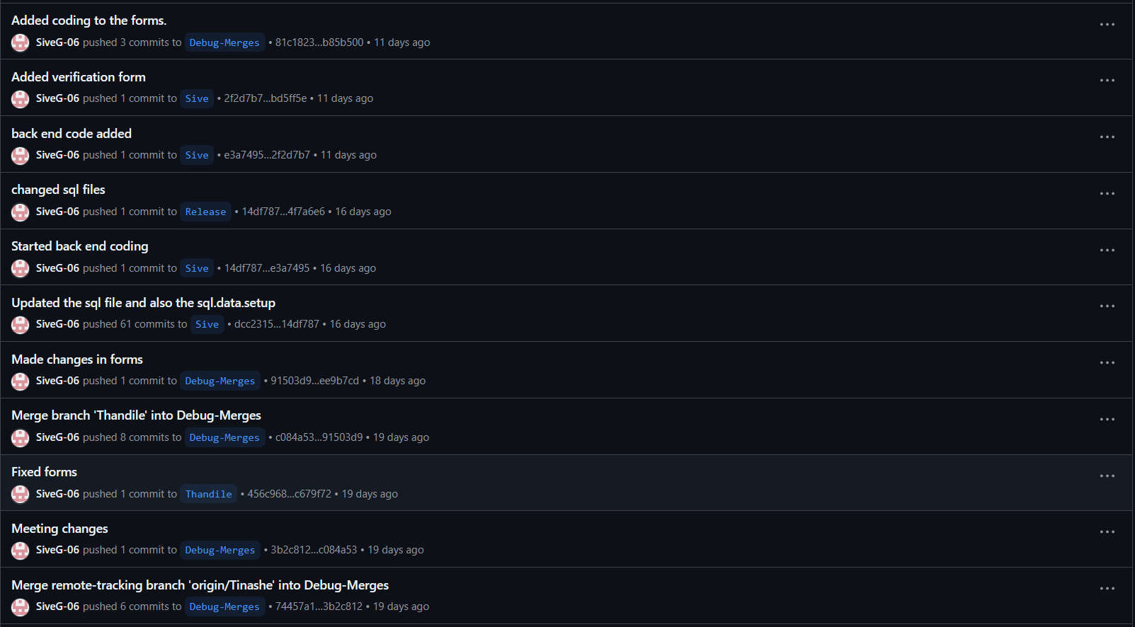
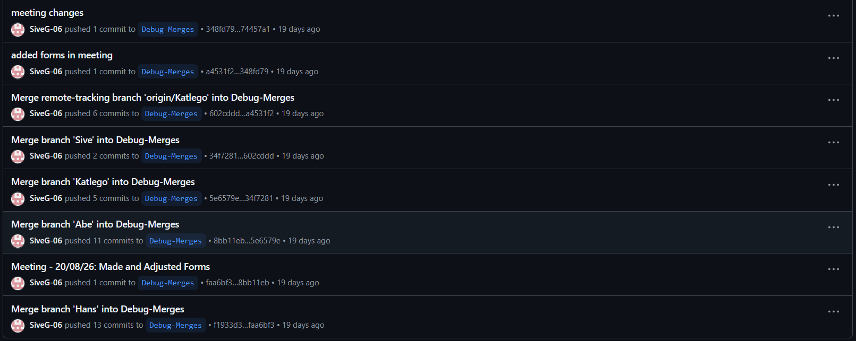
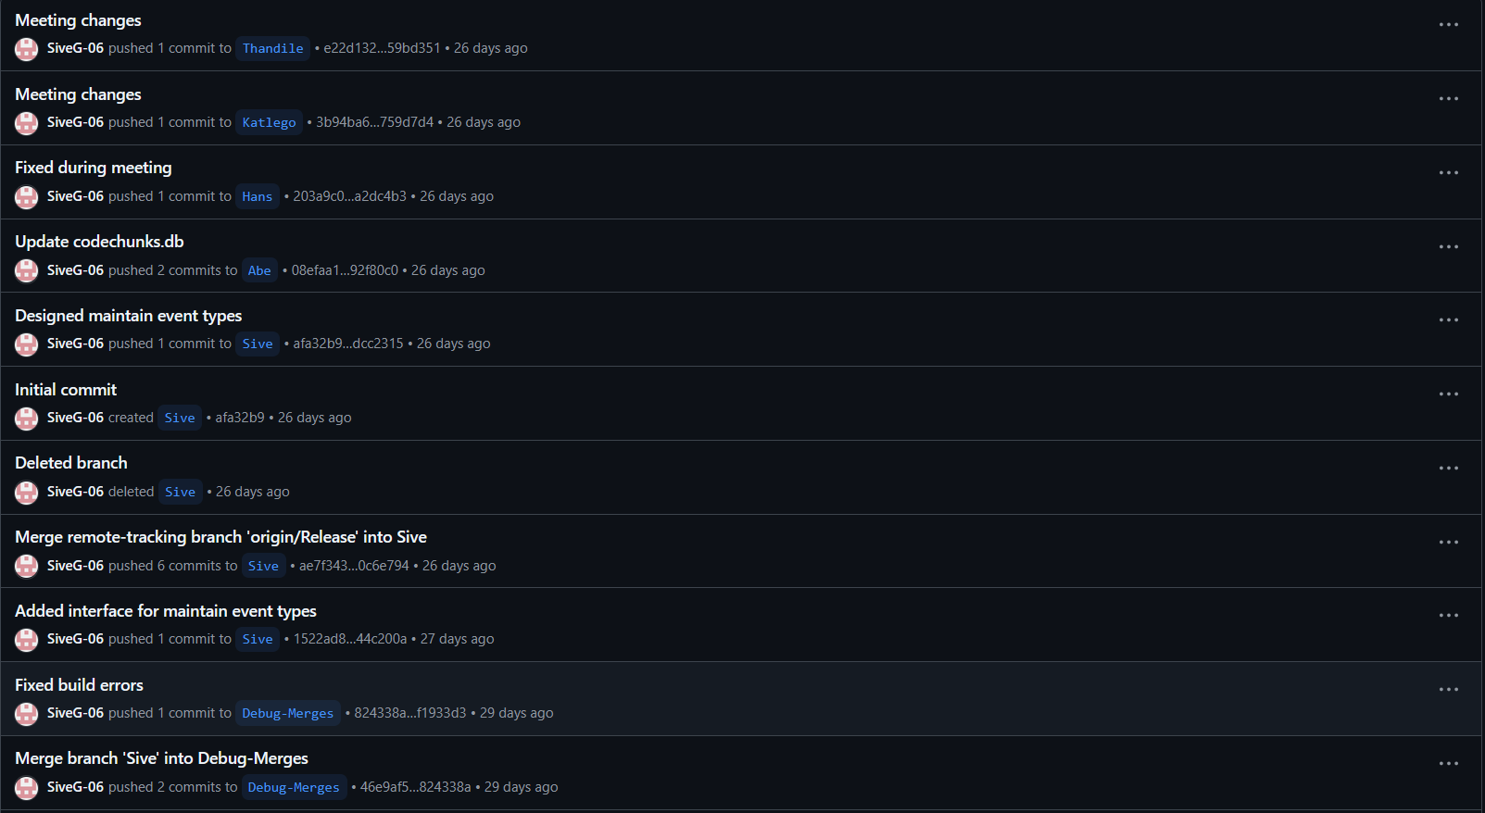

Thandile Jama

